**Clustering as MF**

Below image shows details about k-means clustering i.e we have to find the minimum centroid as given below.

Now lets define z such that zij = 1 if xi belongs to set si of centroid ci

And zij = 0 otherwise

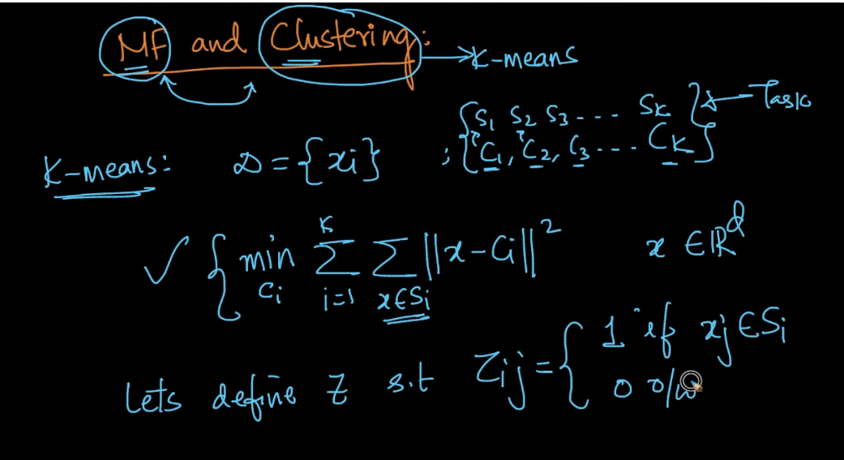

Below it shows z matrix where rows shows clusters (k clusters) and column shows points (k points) , so if jth point present in ith row then only that zij cell contain value 1 otherwise zero.

So by this each column should have only 1 non-empty cell because point can be assigned to only cluster(row in matrix)

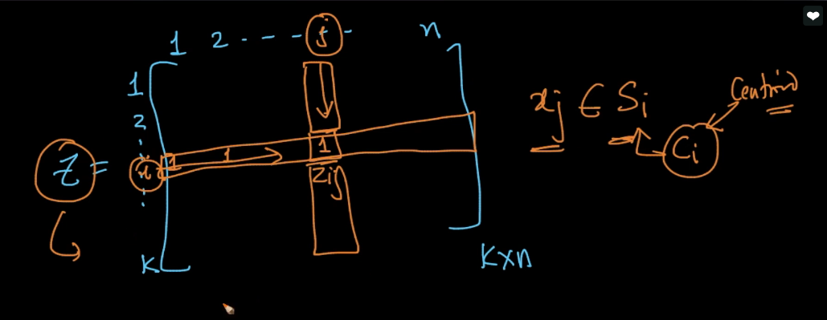

Now we see the transformed form of optimization of k-means here we use zij matrix.

And we replace summation_x_belongs_sj to summation_i=1_n zij

This both have same meaning if first one execute only for those points which belongs to set si of centroid ci and second form execute also for same but it have value 1 for points which belongs to set therefore it performs further operation otherwise it value is 0 therefore it doesn’t perform further operation

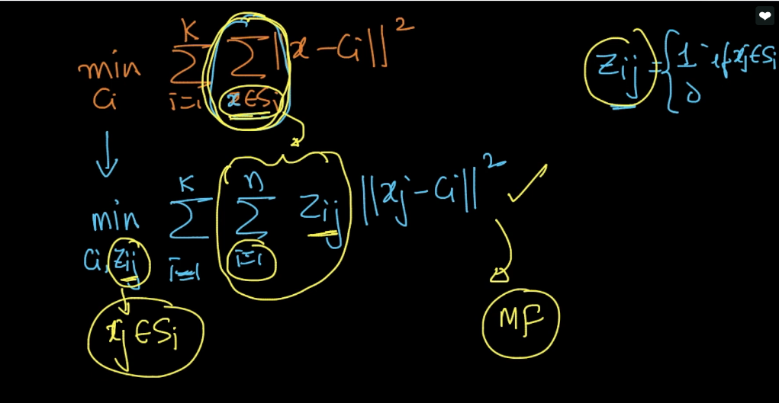

Here we have three matrix X(d*n) it contains all point as a column vector.

C(d*k) it contains all centroid as a column vector

And Z(k*n) we have already discussed.

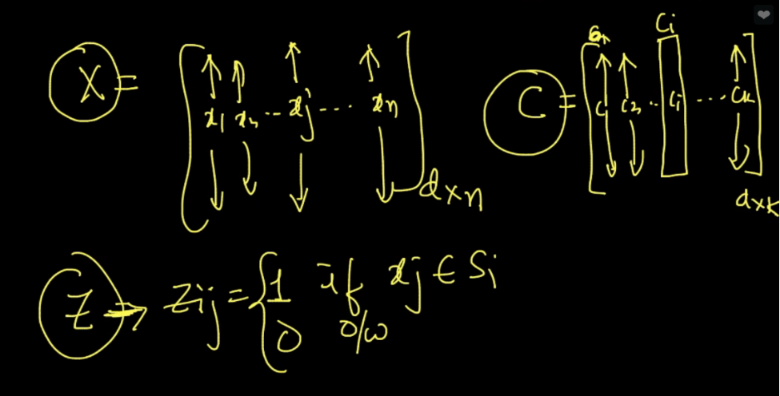

Now we can transform this k-means optimization into MF as shown below.

We minimize c and z before this transformation everything is vector now in this transformed optimization everything is matrix.

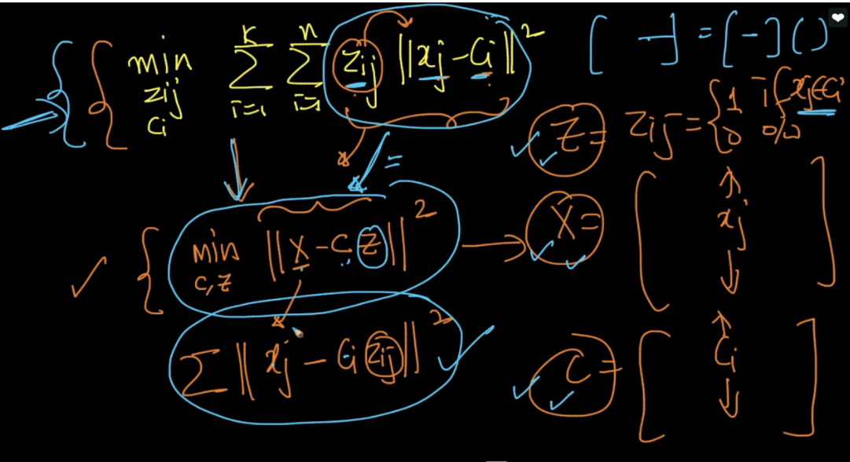

Therefore here matrix MF is x = c * z

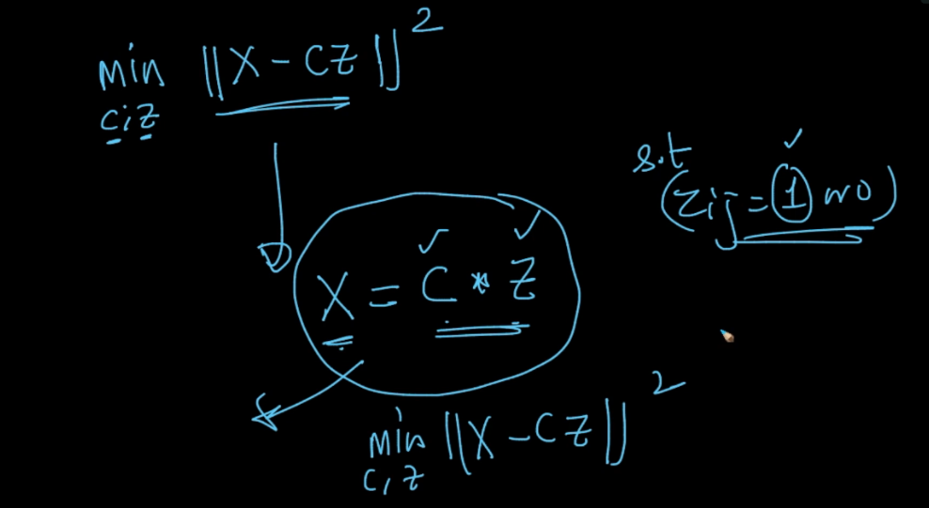

Therefore MF is same as k-means with two constraint first is 0_1 constraint (zij can be 0 or 1)and second is column constraint (sum of elements of zj(columns) = 1 because each column have only 1 non-empty cell)

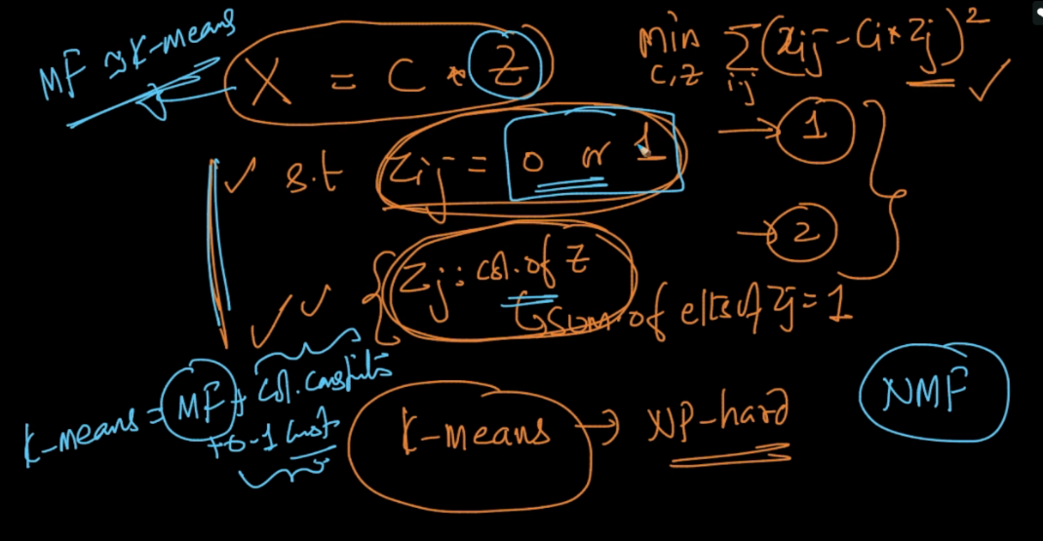

Therefore in this way it transform from MF to NMF to k-means

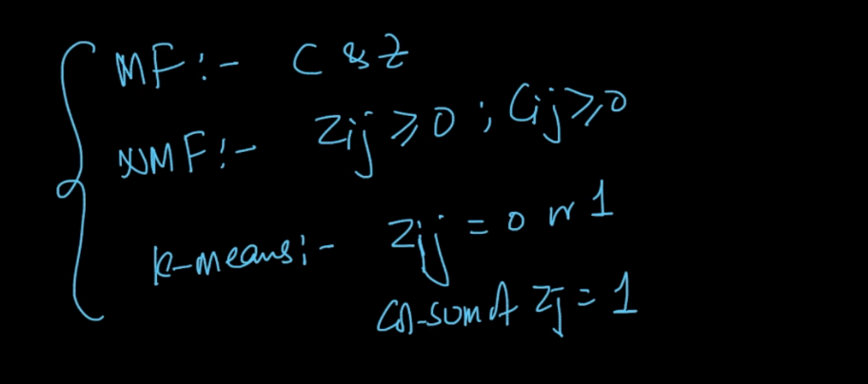

Comments :

